*Video Timestamp*

[*https://youtu.be/osQjStOAci0?t=2h27m41s*](https://youtu.be/osQjStOAci0?t=2h27m41s)

Project README and Log – Orbital- Jeremy Hon and Adrian Chan

Project Title: Cycle of Life

# README

**Overview:** We aim to create a text based narrative driven game. Players will begin playing as a child who has been abused by his parent.

Our ignition slide:

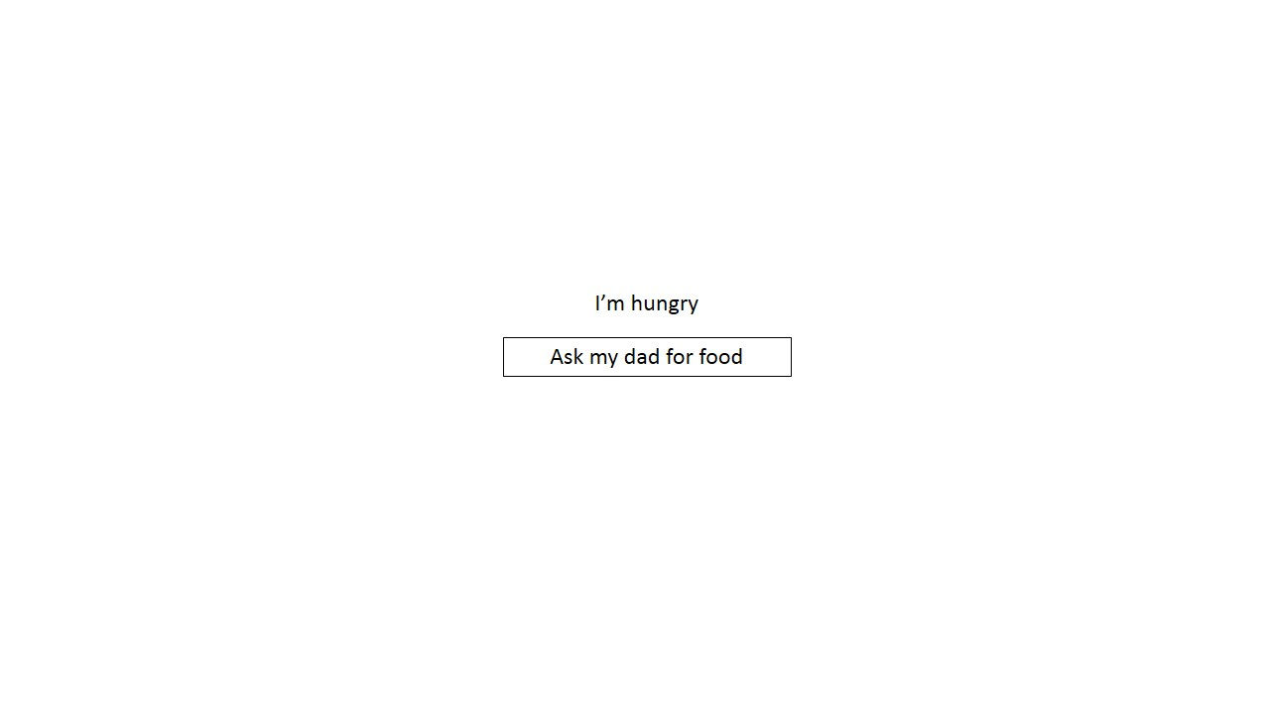

YouTube link to our Ignition presentation:  
<https://youtu.be/osQjStOAci0?t=2h27m41s>

**Planned Features:**

We hope to create an interface that allows players to keep track of the individual statistics (i.e. age, happiness etc). We also hope to create events that the player will have to experience. And from there, create additional choices which players can take that will affect the character. Furthermore, as the character grows up, we hope to introduce a parent-child system where players get to play 2 characters simultaneously, allowing one to interact with each other.

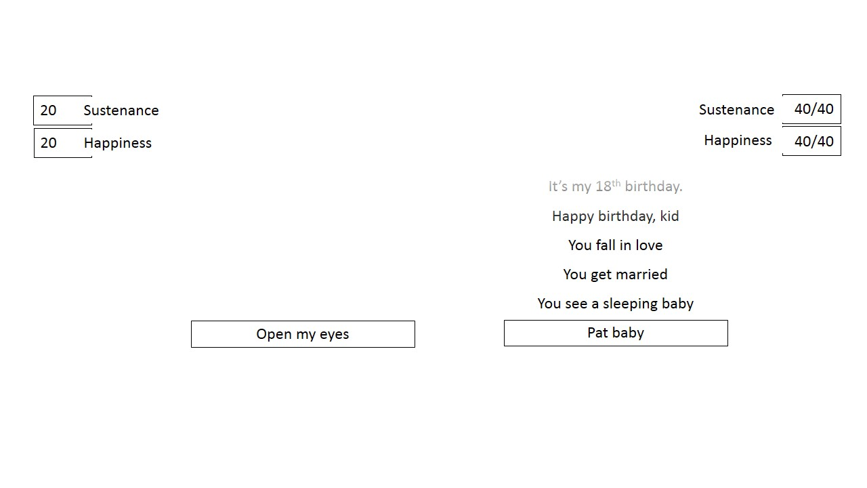

Below: The full interface which players will eventually experience. More features could be included once we have achieved

**Proposed Level of Achievement:**

We believe that we are able to achieve Project Vostok(Beginner) level of achievement. We have both attended and completed Liftoff and attended the bootstrap workshop(something which we wish to implement into our game as well).

# Project Log

**Total hours for Jeremy Hon:**

**Total hours for Adrian Chan: 27**

|  |  |  |  |  |  |
| --- | --- | --- | --- | --- | --- |
| **S/N** | **What** | **Date** | **Jeremy (Duration)** | **Adrian**  **(Duration)** | **Remarks** |
| 1 | Liftoff Day 1 | 11/5/2015 | 8.5 | 8.5 |  |
| 2 | Liftoff Day 2 | 12/5/2015 | 9.5 | 9.5 |  |
| 3 | Learning HTML | 13/5/2015 |  | 2 | Did more Codecademy exercises |
| 4 | Learning BootStrap | --/5/2015 |  |  |  |
| 5 | Learning CSS | --/5/2015 |  |  |  |
| 6 | Attending MC #1 | 20/5/2015 | 2 | 2 | On Bootstrap |
| 7 | Further Bootstrap learning | 21/5/2015 |  | 1.5 |  |
| 8 | Bootstrap exercises | --/5/2015 |  |  |  |
| 9 | Learning JQuery | 29/5/2015 |  | 2 | On Codeacademy and Youtube |
| 10 | Documentation for Evaluation | 5/28/2014 |  | 2 |  |
|  |  |  |  |  |  |
|  | **Total Hours** |  |  | **28.5** |  |